Sample Picture Series Prompt With Accompanying Questions

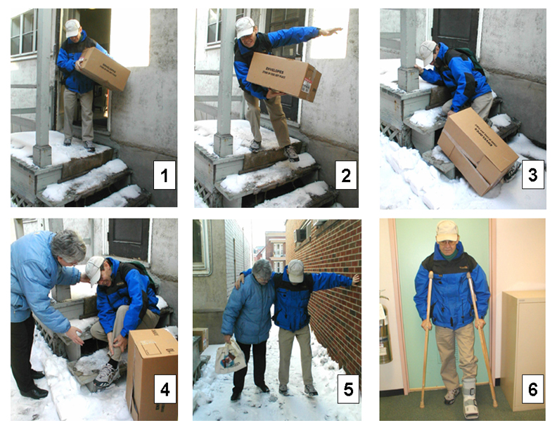

Questions That Tap Grammar

Present progressive
- What’s going on in each of these pictures?

Present simple
- Where do you think this scene takes place?
- Who do you think these people are?
- What precautions do you take when it’s snowy?
- They say that most accidents take place on Mondays. Why do you think that this is so?
- What kinds of jobs are the most dangerous? What specifically makes them dangerous?
- What are the dangers associated with living in a very hot climate?

Past
- What do you think happened between picture 5 and picture 6?
- Have you ever broken any bones? What happened?

Future
- What do you think the man’s condition will be in one week? In one month? In six months?
- How will you prepare for this coming winter/summer? (clothes, house, car)

Modals
- What do you think might be in the box?
- What precautions should the man have taken?
- What should people do when they see an accident?

Conditional
- How could this accident have been avoided?
- What would have happened if he hadn’t been carrying anything? If he had been carrying something heavier?
- What could have happened to the man that would have been more serious?
- What would the woman have done if it had been night-time and she didn’t know the man?
- How would this story be different if the man had been alone?
- How would your life be different if there were no winter season?

Questions That Tap Functions

- Description: Describe the scene in picture 4
- Narration: (1) Tell me the story the pictures show. (2) Tell me about a specific time when you had difficulty during the winter. (3) Tell me about a specific time when you helped someone in need (or when someone helped you).
- Explanation: Why did this accident happen?
- Opinion: Whose fault is this accident (the man’s, the landlord’s)? Explain.
- Comparison: (1) Compare your activities in the winter and the summer. (2) Compare working outdoors with office jobs.
- Hypothesizing: Where could this man be going?
- Defending a position: In some cities, homeowners are responsible for clearing the snow on the sidewalks in front of their homes; in other places, the city does it. Whose responsibility should it be? Why?

Role-Plays

- Giving advice: (1) The man is your friend. Give him some advice about how to recover quickly. (2) Your friend is moving to Canada from a warm country. Give her advice about living here.
- Expressing needs: You are the man. Your office is on the 3rd floor of a building with no elevator. Explain to your office supervisor what special arrangements you may need while you are on crutches.
- Making a complaint: You are the man. Complain to your landlord about snow removal.
- Apologizing: You are the landlord. Apologize to the man for not getting the snow cleared.
- Reprimanding: You are the landlord. Talk with your employee who was supposed to have shoveled the snow.
- Offering to help: You are the woman. Offer to help the man. Ask about his condition and needs.
- Explaining: You are the man. You missed an important deadline because of the accident. Explain to your boss why you didn’t get your work done.

